Practical Index Page
Subject: Compiler Design and Construction
TABLE OF CONTENT
S.N | Details | Submission Date | Signature | Remarks
1. | Write a program to implement DFD that accepts string ending with ab
2. | Write a program for comment validation.
3. | Write a program to recognize string under ‘a*’,’a*b⁺’ , ‘abb’
4. | Write a program to test whether a given identifier is valid or not.
5. | Write a program for lexical Analysis.
6. | Write a program to calculate firstpos(),lastpos()and followpos of any given R.E.
7. | Write a program to remove left recursion from any grammar.
8. | Write a program to find out FIRST and Follow of given grammar.
9. | Write a program to implement LL(1) parser.
10. | Write a program to implement Shift Reduce Parser.
11. | Write a program for intermediate code generate.
12. | Write a program for final code generator.

Lab no: 1 Date:
Title: Write a program to implement DFD that accepts string ending with ab.

Code:
#include <stdio.h>
#include <string.h>

int main() {
char str[100];
int state = 0;
printf("Enter a string for implementing DFD: ");
scanf("%s", str);
int len = strlen(str);

for (int i = 0; i < len; i++) {
char c = str[i];
if (c != 'a' && c != 'b') {
printf("Please enter the valid input {a,b}.\n");
return 1;
}
switch(state) {
case 0:
if (c == 'a') state = 1;
break;
case 1:
if (c == 'b') state = 2;
else if (c == 'a') state = 1;
break;
case 2:
if (c == 'a') state = 1;
else if (c == 'b') state = 0;
break;
}
}
if (state == 2)
printf("String accepted (ends with 'ab')\n");
else
printf("String not accepted\n");
printf("Reeju Pandit\n");
return 0;
}

Lab no: 2 Date:
Title: Write a program for Comment Validation.

Code:
#include <stdio.h>
#include <string.h>
int main() {
char a[100];
int len;
printf("Enter a string:\n");
gets(a);
// Check for single-line comment
if (a[0] == '/' && a[1] == '/') {
printf("It is a single-line comment.\n");
}
// Check for multi-line comment
else if (a[0] == '/' && a[1] == '*') {
len = strlen(a);
if (len >= 4 && a[len - 2] == '*' && a[len - 1] == '/') {
printf("It is a multi-line comment.\n");
} else {
printf("It is not a valid multi-line comment.\n");
}
}
else {
printf("It is not a comment.\n");
}
return 0;
}
Output:

Lab no: 3 Date:
Title: Write a program to recognize string under ‘a*’,’a*b⁺, ‘abb’.

Code:
#include <iostream>
#include <string>
using namespace std;
// Function to check if string is a*
bool is_a_star(const string &s) {
for (int i = 0; i < s.size(); i++)
if (s[i] != 'a') return false;
return true;
}

// Function to check if string is a*b+
bool is_a_star_b_plus(const string &s) {
int i = 0;
while (i < s.size() && s[i] == 'a') i++; // skip a*

int bCount = 0;
while (i < s.size() && s[i] == 'b') {
i++;
bCount++;
}

return (i == s.size() && bCount > 0); // must end with only b+
}

// Function to check if string is exactly "abb"
bool is_abb(const string &s) {
return s == "abb";
}

int main() {
string str;
cout << "Enter string: ";
cin >> str;

if (is_abb(str))
cout << "String matches abb" << endl;
else if (is_a_star(str))
cout << "String matches a*" << endl;
else if (is_a_star_b_plus(str))
cout << "String matches a*b+" << endl;
else
cout << "String does not match any pattern" << endl;

return 0;
}

Output:
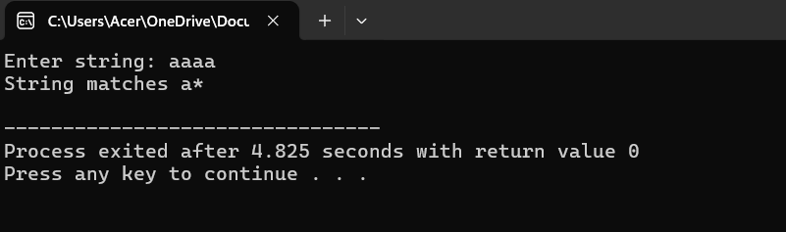
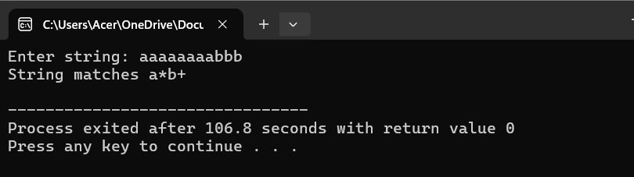
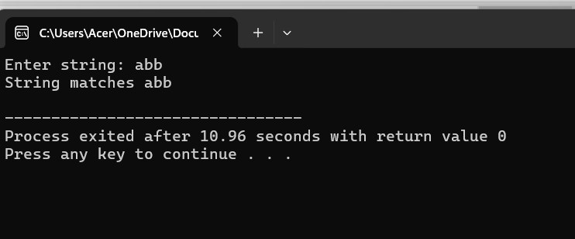

Lab no: 4 Date:
Title: Write a program to test whether a given identifier is valid or not.

Code:
#include <stdio.h>
#include <ctype.h>
int main() {
char identifier[100];
int i;
int isValid = 1;
printf("Enter identifier: ");
scanf("%s", identifier);

// First character must be a letter or underscore
if (!(isalpha(identifier[0]) || identifier[0] == '_')) {
isValid = 0;
} else {
for (i = 1; identifier[i] != '\0'; i++) {
if (!(isalnum(identifier[i]) || identifier[i] == '_')) {
isValid = 0;
break;
}
}
}
if (isValid)
printf("Valid identifier\n");
else
printf("Invalid identifier\n");
printf("Reeju Pandit\n");
return 0;
}
Output:
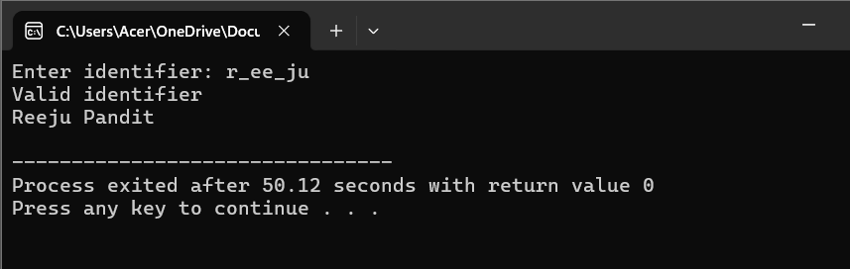
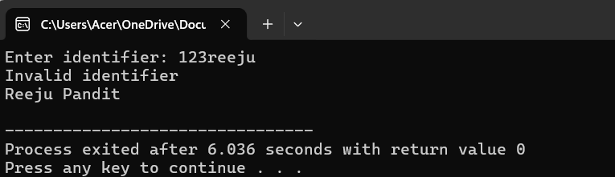
Lab no: 5 Date:
Title: Write a program for lexical analyzer.

Code:
#include <stdio.h>
#include <ctype.h>

int main() {
char input[100];
int i = 0;

printf("Enter an expression: ");
fgets(input, sizeof(input), stdin);

printf("\nTokens:\n");

while (input[i] != '\0') {
if (isalpha(input[i])) {
printf("Identifier: %c\n", input[i]);
}
else if (isdigit(input[i])) {
printf("Number: %c\n", input[i]);
}
else if (input[i] == ' ' || input[i] == '\n') {
// Skip whitespace and newline
}
else {
printf("Special Symbol: %c\n", input[i]);
}
i++;
}
printf("Reeju Pandit\n");
return 0;
}
Output:
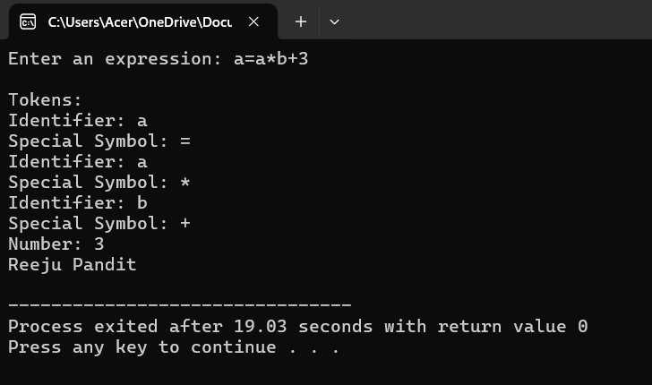
Lab no: 6 Date:
Title: Write a program to calculate firstpos(), lastpos()and followpose() of given regular expression.

Code:
#include <stdio.h>
#include <stdlib.h>
#include <string.h>
#include <stdbool.h>
#include <ctype.h>
#define MAX 128
typedef struct Node {
char sym;
struct Node *left, *right;
int pos;
bool nullable;
int firstpos[MAX], lastpos[MAX];
int firstCount, lastCount;
} Node;

typedef struct { Node* data[MAX]; int top; } Stack;

void init(Stack* s){ s->top=-1; }
void push(Stack* s, Node* n){ s->data[++s->top]=n; }
Node* pop(Stack* s){ return s->data[s->top--]; }

int globalPos = 1;
int followpos[MAX][MAX] = {0};
int fCount[MAX] = {0};

bool isOperand(char c){ return isalnum(c); }

Node* createNode(char sym, Node* l, Node* r){
Node* n = (Node*)malloc(sizeof(Node));
n->sym = sym; n->left = l; n->right = r;
n->nullable = false; n->firstCount = n->lastCount = 0; n->pos = -1;
return n;
}

void addSet(int* set, int* count, int val){
for(int i=0;i<*count;i++) if(set[i]==val) return;
set[(*count)++] = val;
}

void unionSet(int* dst, int* dcount, int* src, int scount){
for(int i=0;i<scount;i++) addSet(dst,dcount,src[i]);
}

Node* buildTree(char* postfix){
Stack s; init(&s);
for(int i=0; postfix[i]; i++){
char c = postfix[i];
if(isOperand(c)){
Node* n = createNode(c,NULL,NULL);
n->pos = globalPos++;
n->firstpos[n->firstCount++] = n->pos;
n->lastpos[n->lastCount++] = n->pos;
push(&s,n);
} else if(c=='*'){
Node* a = pop(&s);
Node* n = createNode(c,a,NULL);
n->nullable = true;
unionSet(n->firstpos,&n->firstCount,a->firstpos,a->firstCount);
unionSet(n->lastpos,&n->lastCount,a->lastpos,a->lastCount);
push(&s,n);
} else if(c=='.'){
Node* b = pop(&s); Node* a = pop(&s);
Node* n = createNode(c,a,b);
n->nullable = a->nullable && b->nullable;
unionSet(n->firstpos,&n->firstCount,a->firstpos,a->firstCount);
if(a->nullable) unionSet(n->firstpos,&n->firstCount,b->firstpos,b->firstCount);
unionSet(n->lastpos,&n->lastCount,b->lastpos,b->lastCount);
if(b->nullable) unionSet(n->lastpos,&n->lastCount,a->lastpos,a->lastCount);
push(&s,n);
} else if(c=='|'){
Node* b = pop(&s); Node* a = pop(&s);
Node* n = createNode(c,a,b);
n->nullable = a->nullable || b->nullable;
unionSet(n->firstpos,&n->firstCount,a->firstpos,a->firstCount);
unionSet(n->firstpos,&n->firstCount,b->firstpos,b->firstCount);
unionSet(n->lastpos,&n->lastCount,a->lastpos,a->lastCount);
unionSet(n->lastpos,&n->lastCount,b->lastpos,b->lastCount);
push(&s,n);
}
}
return pop(&s);
}

void computeFollowpos(Node* n){
if(!n) return;
computeFollowpos(n->left);
computeFollowpos(n->right);
if(n->sym=='.'){
for(int i=0;i<n->left->lastCount;i++){
int p = n->left->lastpos[i];
unionSet(followpos[p],&fCount[p],n->right->firstpos,n->right->firstCount);
}
} else if(n->sym=='*'){
for(int i=0;i<n->lastCount;i++){
int p = n->lastpos[i];
unionSet(followpos[p],&fCount[p],n->firstpos,n->firstCount);
}
}
}

void printSet(int* set, int count){
printf("{");
for(int i=0;i<count;i++){ if(i>0) printf(","); printf("%d",set[i]); }
printf("}\n");
}

void printNodeInfo(Node* n, int type){
if(!n) return;
printNodeInfo(n->left,type);
printNodeInfo(n->right,type);
if(type==1){ // firstpos
printf("Node '%c' firstpos=",n->sym);
printSet(n->firstpos,n->firstCount);
} else if(type==2){ // lastpos
printf("Node '%c' lastpos=",n->sym);
printSet(n->lastpos,n->lastCount);
} else if(type==3){ // followpos
if(n->pos!=-1){
printf("Node '%c' followpos=",n->sym);
printSet(followpos[n->pos],fCount[n->pos]);
}
}
}

int main(){
char postfix[100];
printf("Reeju Pandit\n");
printf("Enter postfix regex: ");
scanf("%s",postfix);

Node* root = buildTree(postfix);
computeFollowpos(root);

int choice;
do{
printf("\nMenu:\n1. Firstpos\n2. Lastpos\n3. Followpos\n4. Exit\nEnter choice: ");
scanf("%d",&choice);
switch(choice){
case 1: printNodeInfo(root,1); break;
case 2: printNodeInfo(root,2); break;
case 3: printNodeInfo(root,3); break;
case 4: printf("Exiting...\n"); break;
default: printf("Invalid choice!\n");
}
}while(choice!=4);
return 0;
}
Output:
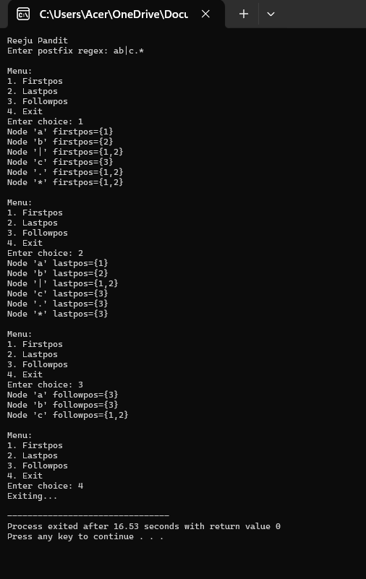

Lab no: 7 Date:
Title: Write a program to remove left recursion from any grammar.

Code:
#include <stdio.h>
#include <string.h>

#define MAX 10
#define SIZE 50

int main() {
char nonTerminal; // The grammar's non-terminal (A, B, etc.)
int n; // Number of productions
char prod[MAX][SIZE]; // Original productions
char alpha[MAX][SIZE]; // Left-recursive parts
char beta[MAX][SIZE]; // Non-left-recursive parts
int alphaCount = 0, betaCount = 0;

// Input the non-terminal
printf("Enter the non-terminal: ");
scanf(" %c", &nonTerminal);

// Input the number of productions
printf("Enter the number of productions for %c: ", nonTerminal);
scanf("%d", &n);

// Input all productions
printf("Enter the right-hand side of each production:\n");
for(int i = 0; i < n; i++){
scanf("%s", prod[i]);
}

// Separate left-recursive and non-left-recursive productions
for(int i = 0; i < n; i++){
if(prod[i][0] == nonTerminal){ // Left recursion detected
strcpy(alpha[alphaCount++], prod[i] + 1); // Remove the first character (A)
} else {
strcpy(beta[betaCount++], prod[i]); // Non-left-recursive
}
}

// If no left recursion, inform user
if(alphaCount == 0){
printf("No left recursion detected for %c.\n", nonTerminal);
return 0;
}

// Print the new grammar after removing left recursion
printf("\nGrammar after removing left recursion:\n");

// New production for original non-terminal: A -> ßA'
printf("%c -> ", nonTerminal);
for(int i = 0; i < betaCount; i++){
printf("%s%c'", beta[i], nonTerminal);
if(i != betaCount - 1) printf(" | ");
}
printf("\n");

// New production for the helper non-terminal: A' -> aA' | e
printf("%c' -> ", nonTerminal);
for(int i = 0; i < alphaCount; i++){
printf("%s%c'", alpha[i], nonTerminal);
if(i != alphaCount - 1) printf(" | ");
}
printf(" | e\n");

return 0;
}
Output:
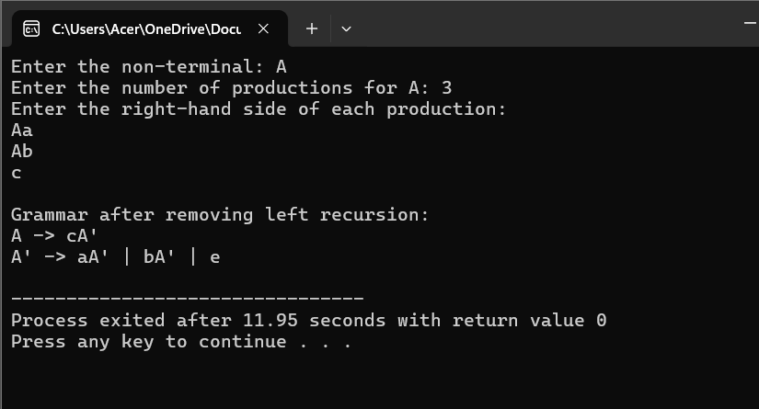

Lab no: 8 Date:
Title: Write a program to find FIRST and FOLLOW of given grammar.

Code:
//first and follow pose

#include <stdio.h>
#include <string.h>
#include <ctype.h>

#define MAX_NONTERM 26
#define MAX_RULES 128
#define MAX_LEN 128

typedef struct {
int rule_count;
char productions[MAX_RULES][MAX_LEN];
} NonTerminal;

NonTerminal grammar[MAX_NONTERM];
int nt_exists[MAX_NONTERM];
char nt_sequence[MAX_NONTERM];
int seq_count = 0;
int FIRST[MAX_NONTERM][128];
int FOLLOW[MAX_NONTERM][128];

int has_epsilon(int set[]) {
return set['e'] != 0;
}

int add_symbol_to_set(int set[], int symbol) {
if(!set[symbol]) {
set[symbol] = 1;
return 1;
}
return 0;
}

int merge_sets_excluding(int dest[], int src[], int exclude) {
int changed = 0;
for(int i = 0; i < 128; i++) {
if(i == exclude) continue;
if(src[i] && !dest[i]) {
dest[i] = 1;
changed = 1;
}
}
return changed;
}

void remove_whitespace(char *s) {
int w = 0;
for(int r = 0; s[r]; r++) {
if(s[r] != ' ' && s[r] != '\t' && s[r] != '\r') {
s[w++] = s[r];
}
}
s[w] = '\0';
}

void parse_production(const char *line) {
char buffer[MAX_LEN];
strncpy(buffer, line, MAX_LEN - 1);
buffer[MAX_LEN - 1] = '\0';
buffer[strcspn(buffer, "\n")] = '\0';
remove_whitespace(buffer);
if(buffer[0] == '\0') return;

char head = buffer[0];
if(!isupper((unsigned char)head)) return;
int idx = head - 'A';

if(!nt_exists[idx]) {
nt_exists[idx] = 1;
nt_sequence[seq_count++] = head;
}

const char *rhs_start = strstr(buffer, "->");
if(!rhs_start) return;
rhs_start += 2;

char temp[MAX_LEN]; int t = 0;
for(int i = 0;; i++) {
char ch = rhs_start[i];
if(ch == '|' || ch == '\0') {
temp[t] = '\0';
if(t > 0) {
strncpy(grammar[idx].productions[grammar[idx].rule_count], temp, MAX_LEN - 1);
grammar[idx].productions[grammar[idx].rule_count][MAX_LEN - 1] = '\0';
grammar[idx].rule_count++;
}
t = 0;
if(ch == '\0') break;
} else if(t < MAX_LEN - 1) {
temp[t++] = ch;
}
}
}

void first_of_string(const char *str, int out_set[], int *has_e) {
for(int i = 0; i < 128; i++) out_set[i] = 0;
int nullable = 1;

if(str[0] == '\0') {
*has_e = 1;
return;
}

for(int i = 0; str[i]; i++) {
char X = str[i];
if(X == 'e') continue;
if(isupper((unsigned char)X)) {
int idx = X - 'A';
merge_sets_excluding(out_set, FIRST[idx], 'e');
if(!FIRST[idx]['e']) {
nullable = 0;
break;
}
} else {
add_symbol_to_set(out_set, (unsigned char)X);
nullable = 0;
break;
}
}
*has_e = nullable;
}

void compute_FIRST() {
int changed = 1;
while(changed) {
changed = 0;
for(int i = 0; i < seq_count; i++) {
int A = nt_sequence[i] - 'A';
for(int r = 0; r < grammar[A].rule_count; r++) {
const char *prod = grammar[A].productions[r];
if(strcmp(prod, "e") == 0) {
if(add_symbol_to_set(FIRST[A], 'e')) changed = 1;
continue;
}
int temp[128], has_e;
first_of_string(prod, temp, &has_e);
if(merge_sets_excluding(FIRST[A], temp, -1)) changed = 1;
if(has_e && add_symbol_to_set(FIRST[A], 'e')) changed = 1;
}
}
}
}

void compute_FOLLOW() {
if(seq_count > 0) FOLLOW[nt_sequence[0] - 'A']['$'] = 1;

int changed = 1;
while(changed) {
changed = 0;
for(int i = 0; i < seq_count; i++) {
int A = nt_sequence[i] - 'A';
for(int r = 0; r < grammar[A].rule_count; r++) {
const char *prod = grammar[A].productions[r];
int len = strlen(prod);
for(int j = 0; j < len; j++) {
char B = prod[j];
if(isupper((unsigned char)B)) {
int idxB = B - 'A';
char beta[MAX_LEN]; int b = 0;
for(int k = j + 1; k < len && b < MAX_LEN - 1; k++) beta[b++] = prod[k];
beta[b] = '\0';

int temp[128], has_e;
first_of_string(beta, temp, &has_e);
if(merge_sets_excluding(FOLLOW[idxB], temp, 'e')) changed = 1;
if(has_e || beta[0] == '\0') {
if(merge_sets_excluding(FOLLOW[idxB], FOLLOW[A], -1)) changed = 1;
}
}
}
}
}
}
}

void print_set(const char *label, char nt, int set[]) {
printf("%s(%c) = { ", label, nt);
int first = 1;
for(int i = 0; i < 128; i++) {
if(set[i]) {
if(!first) printf(", ");
printf("%c", i);
first = 0;
}
}
printf(" }\n");
}

int main() {
int n;
char line[MAX_LEN];

memset(grammar, 0, sizeof(grammar));
memset(nt_exists, 0, sizeof(nt_exists));
memset(nt_sequence, 0, sizeof(nt_sequence));
seq_count = 0;
memset(FIRST, 0, sizeof(FIRST));
memset(FOLLOW, 0, sizeof(FOLLOW));

printf("Enter the number of productions: ");
if(scanf("%d", &n) != 1) return 0;
getchar();

printf("Enter the productions:\n");
for(int i = 0; i < n; i++) {
if(!fgets(line, sizeof(line), stdin)) break;
if(line[0] == '\n' || line[0] == '\0') { i--; continue; }
parse_production(line);
}

compute_FIRST();
compute_FOLLOW();

printf("\nThe firstpos and followpos of the production are:\n");
for(int i = 0; i < seq_count; i++) {
char nt = nt_sequence[i];
print_set("FIRST", nt, FIRST[nt - 'A']);
print_set("FOLLOW", nt, FOLLOW[nt - 'A']);
}
printf("By Reeju Pandit\n");
return 0;
}

Output:
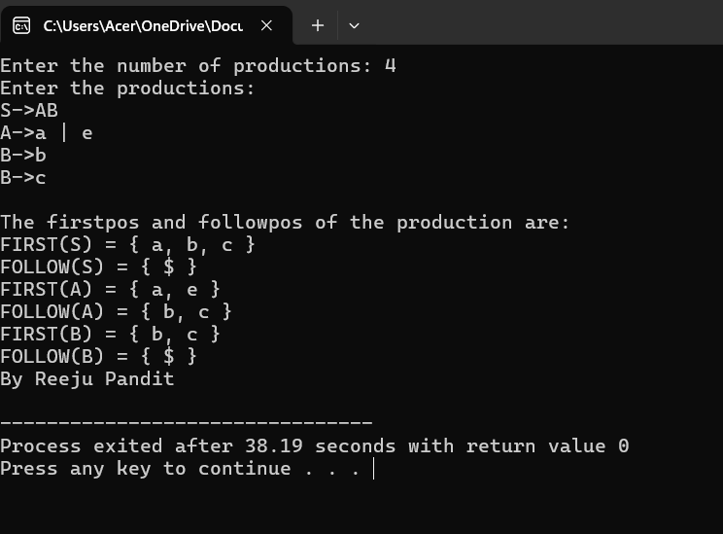

Lab no: 9 Date:
Title: Write a program to implement LL(1)parser.

Code:
#include <stdio.h>
#include <string.h>
#include <process.h>

char s[20], stack[20];

int main()
{
char m[5][6][4] = {"tb", " ", " ", "tb", " ", " ", " ", "+tb", " ", " ", "n", "n", "fc", " ", " ", "fc", " ", " ", " ", "n", "*fc", " a", "n", "n", "i", " ", " ", "(e)", " ", " "};
int size[5][6] = {2, 0, 0, 2, 0, 0, 0, 3, 0, 0, 1, 1, 2, 0, 0, 2, 0, 0, 0, 1, 3, 0, 1, 1, 1, 0, 0, 3, 0, 0};
int i, j, k, n, str1, str2;
printf("Enter the input string: ");
scanf("%s", s);
strcat(s, "$");
n = strlen(s);
stack[0] = '$';
stack[1] = 'e';

i = 1;
j = 0;
printf("Stack\t\tInput\n");
printf("_________________________\n");
while ((stack[i] != '$') && (s[j] != '$'))
{
if (stack[i] == s[j])
{
i--;
j++;
}
switch (stack[i])
{
case 'e':
str1 = 0;
break;
case 'b':
str1 = 1;
break;
case 't':
str1 = 2;
break;
case 'c':
str1 = 3;
break;
case 'f':
str1 = 4;
break;
}
switch (s[j])
{
case 'i':
str2 = 0;
break;
case '+':
str2 = 1;
break;
case '*':
str2 = 2;
break;
case '(':
str2 = 3;
break;
case ')':
str2 = 4;
break;
case '$':
str2 = 5;
break;
}
if (m[str1][str2][0] == '\0')
{
printf("\nERROR");
exit(0);
}
else if (m[str1][str2][0] == 'n')
i--;
else if (m[str1][str2][0] == 'i')
stack[i] = 'i';
else
{
for (k = size[str1][str2] - 1; k >= 0; k--)
stack[i++] = m[str1][str2][k];
i--;
}
for (k = 0; k <= i; k++)
printf("%c", stack[k]);
printf("\t\t");
for (k = j; k <= n; k++)
printf("%c", s[k]);
printf("\n");
}
printf("\nSUCCESS");
return 0;
}

Output:
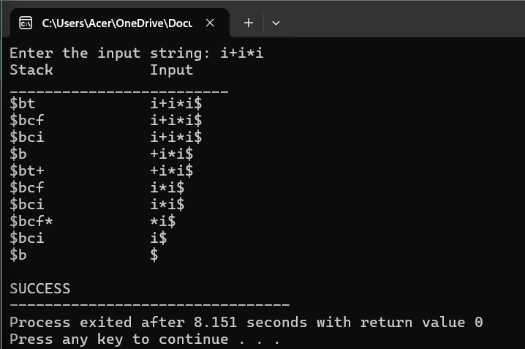

Lab no:10 Date:
Title: Write a program to implement Shift Reduce Parser.

Code:
#include <stdio.h>
#include <stdlib.h>
#include <conio.h>
#include <string.h>

char ip_sym[15], stack[15];
int ip_ptr = 0, st_ptr = 0, len, i;
char temp[2], temp2[2];
char act[15];

void check();

int main()
{
printf("GRAMMAR:");
printf("\nE -> E + E\nE -> E / E");
printf("\nE -> E * E\nE -> a / b");
printf("\nEnter the input symbol:\t");
gets(ip_sym);
printf("\n\t Stack implementation table\n");
printf("\nStack\t\t Input symbol\t\t Action");
printf("\n______\t\t ____________\t\t ______\n");
printf("\n $\t\t%s$\t\t\t--", ip_sym);
strcpy(act, "Shift ");
temp[0] = ip_sym[ip_ptr];
temp[1] = '\0';
strcat(act, temp);
len = strlen(ip_sym);
for (i = 0; i <= len - 1; i++)
{
stack[st_ptr] = ip_sym[ip_ptr];
stack[st_ptr + 1] = '\0';
ip_sym[ip_ptr] = ' ';
ip_ptr++;
printf("\n $%s\t\t%s$\t\t\t%s", stack, ip_sym, act);
strcpy(act, "shift ");
temp[0] = ip_sym[ip_ptr];
temp[1] = '\0';
strcat(act, temp);
check();
st_ptr++;
}
printf("Reeju Pandit\n");
return 0;
}

void check()
{
int flag = 0;
temp2[0] = stack[st_ptr];
temp2[1] = '\0';
if ((!strcmpi(temp2, "a")) || (!strcmpi(temp2, "b")))
{
stack[st_ptr] = 'E';
if (!strcmpi(temp2, "a"))
printf("\n $%s\t\t%s$\t\t\tE->a", stack, ip_sym);
else
printf("\n $%s\t\t%s$\t\t\tE->b", stack, ip_sym);
flag = 1;
}
if ((!strcmpi(temp2, "+")) || (strcmpi(temp2, "*")) || (!strcmpi(temp2, "/")))
{
flag = 1;
}
if ((!strcmpi(stack, "E+E")) || (!strcmpi(stack, "E/E")) || (!strcmpi(stack, "E*E")))
{
strcpy(stack, "E");
st_ptr = 0;
if (!strcmpi(stack, "E+E"))
printf("\n $%s\t\t%s$\t\t\tE->E+E", stack, ip_sym);
else if (!strcmpi(stack, "E/E"))
printf("\n $%s\t\t %s$\t\t\tE->E/E", stack, ip_sym);
else
printf("\n $%s\t\t%s$\t\t\tE->E*E", stack, ip_sym);
flag = 1;
}
if (!strcmpi(stack, "E") && ip_ptr == len)
{
printf("\n $%s\t\t%s$\t\t\tACCEPT", stack, ip_sym);
return;
}
if (flag == 0)
{
printf("\n%s\t\t\t%s\t\t REJECT", stack, ip_sym);
return;
}

return;
}

Output:
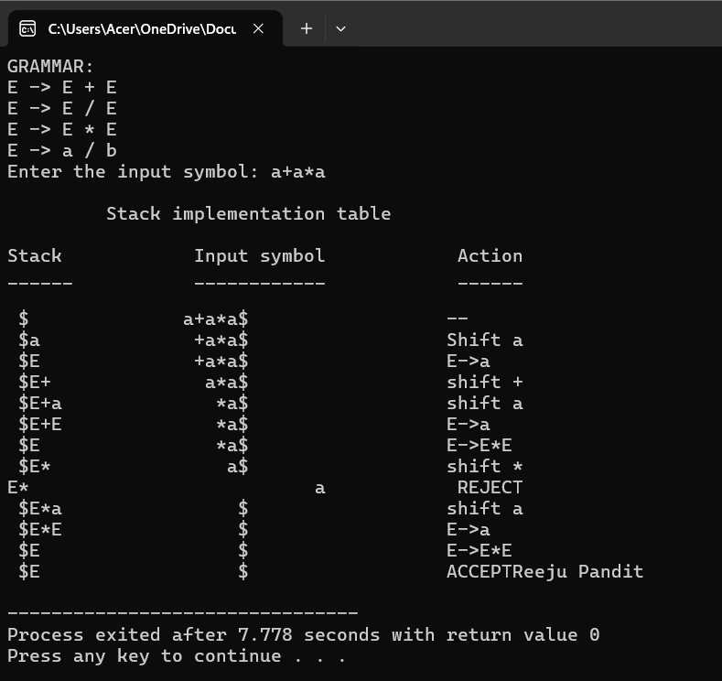

Lab no:11 Date:
Title: Write a program to intermediate code generator..

Code:
#include <stdio.h>
#include <string.h>
#include <ctype.h>

int tempNo = 1;

void generateCode(char expr[]) {
int len = strlen(expr);
char left[10], right[10];
char temp[2] = "T";

// Process * and / first
for(int i=0; i<len; i++) {
if(expr[i] == '*' || expr[i] == '/') {
left[0] = expr[i-1];
left[1] = '\0';
right[0] = expr[i+1];
right[1] = '\0';

printf("T%d := %s %c %s\n", tempNo, left, expr[i], right);

expr[i-1] = 'T';
expr[i] = '\0';
expr[i+1] = '\0';
tempNo++;
}
}

// Then process + and -
for(int i=0; i<len; i++) {
if(expr[i] == '+' || expr[i] == '-') {
left[0] = expr[i-1];
left[1] = '\0';
right[0] = expr[i+1];
right[1] = '\0';

printf("T%d := %s %c %s\n", tempNo, left, expr[i], right);

expr[i-1] = 'T';
expr[i] = '\0';
expr[i+1] = '\0';
tempNo++;
}
}
}

int main() {
char expr[50];
printf("Enter the expression: ");
scanf("%s", expr);

printf("Intermediate code:\n");
generateCode(expr);

return 0;
}
Output:
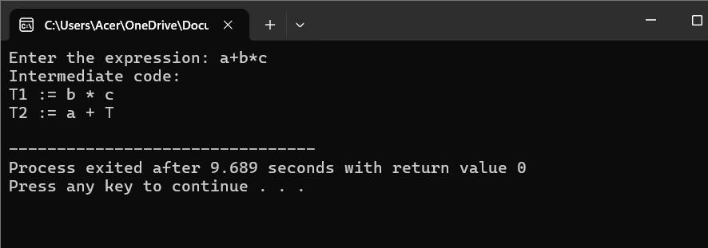

Lab no:12 Date:
Title: Write a program to final code generator.

Code:
#include <stdio.h>
#include <string.h>

char op[2], arg1[5], arg2[5], result[5];

int main()
{
FILE *fp1, *fp2;

// Try to open input.txt in the current folder
fp1 = fopen("input.txt", "r");
if (fp1 == NULL) {
printf("input.txt not found! Please enter expressions manually.\n");
// If file not found, open temporary file for writing input
fp1 = fopen("input_temp.txt", "w+");
if (fp1 == NULL) {
printf("Cannot create temporary input file. Exiting.\n");
return 1;
}
printf("Enter expressions (operator arg1 arg2 result) one per line.\n");
printf("Enter 'done' to finish input.\n");
while (1) {
char line[50];
fgets(line, sizeof(line), stdin);
if (strncmp(line, "done", 4) == 0) break;
fputs(line, fp1);
}
rewind(fp1); // Reset file pointer to start
}

fp2 = fopen("output.txt", "w");
if (fp2 == NULL) {
printf("Cannot create output.txt. Exiting.\n");
return 1;
}

while (fscanf(fp1, "%s", op) == 1) {
fscanf(fp1, "%s %s %s", arg1, arg2, result);
if (strcmp(op, "+") == 0) {
fprintf(fp2, "MOV R0, %s\n", arg1);
fprintf(fp2, "ADD R0, %s\n", arg2);
fprintf(fp2, "MOV %s, R0\n", result);
}
else if (strcmp(op, "*") == 0) {
fprintf(fp2, "MOV R0, %s\n", arg1);
fprintf(fp2, "MUL R0, %s\n", arg2);
fprintf(fp2, "MOV %s, R0\n", result);
}
else if (strcmp(op, "-") == 0) {
fprintf(fp2, "MOV R0, %s\n", arg1);
fprintf(fp2, "SUB R0, %s\n", arg2);
fprintf(fp2, "MOV %s, R0\n", result);
}
else if (strcmp(op, "/") == 0) {
fprintf(fp2, "MOV R0, %s\n", arg1);
fprintf(fp2, "DIV R0, %s\n", arg2);
fprintf(fp2, "MOV %s, R0\n", result);
}
else if (strcmp(op, "=") == 0) {
fprintf(fp2, "MOV R0, %s\n", arg1);
fprintf(fp2, "MOV %s, R0\n", result);
}
}
fclose(fp1);
fclose(fp2);

printf("Code generation complete! Check output.txt for results.\n");
return 0;
}
Output:
